1. Starting the ambari server

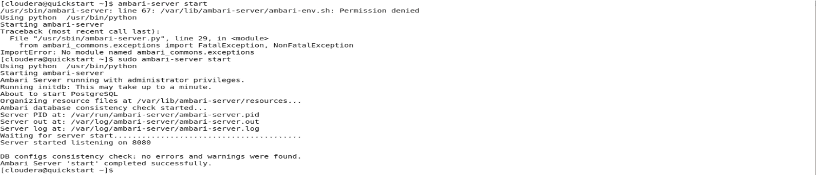

1. Checking the status of Ambari server

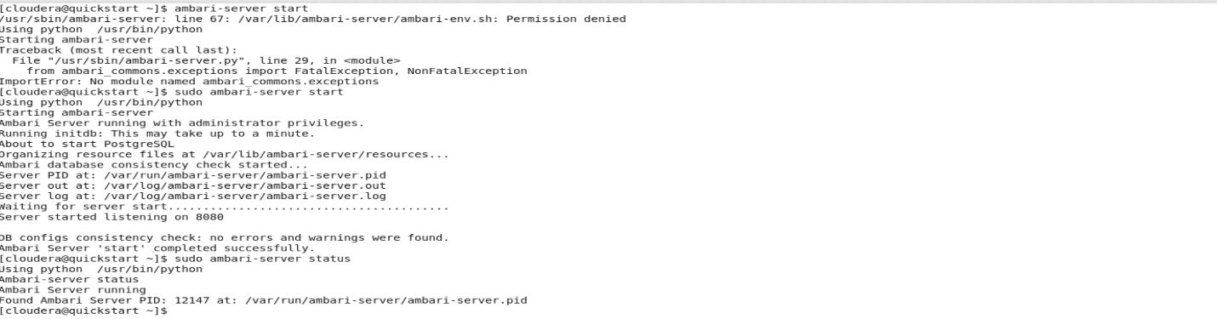

1. Logging to Apache server

http://<your_ambari_server>:8080

your default ambari server host is located at <http://c6401.ambari.apache.org:8080>

But in VM, you should give

<http://quickstart.cloudera:8080>

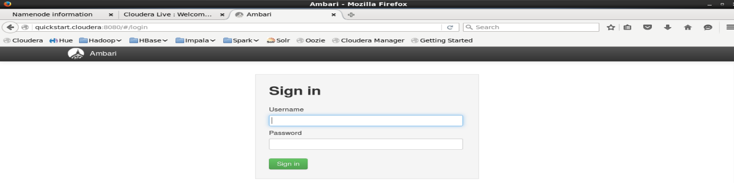

1. Loggin in with id and password

Userid = admin, password = admin

